CODE SMELL

* LONG METHOD

**Location in the code:** src/main/java/org/jabref/gui/groups/GroupTreeView

The method initialize() on the class GroupTreeView has 198 lines of code.

This method starts at the line 140.

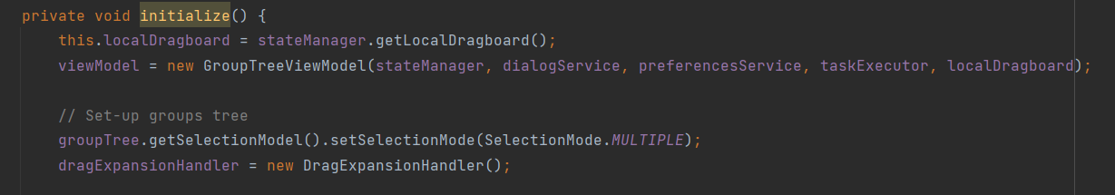

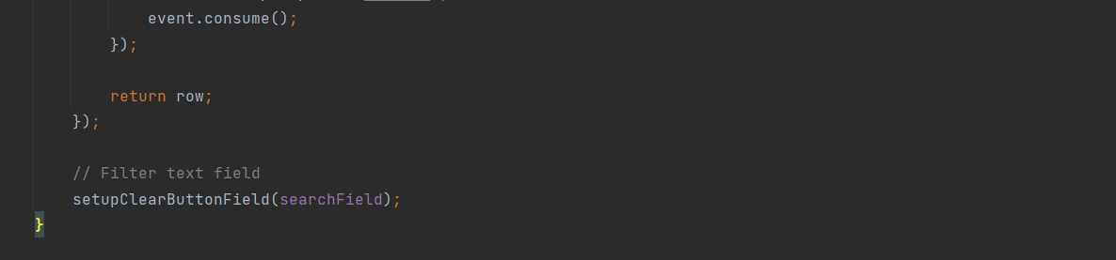And ends at the line 338.

The initialize() method, with this many lines of code, is very complicated to understand. Maybe divide this method into smaller ones would decrease the complexity and make it easier to read.